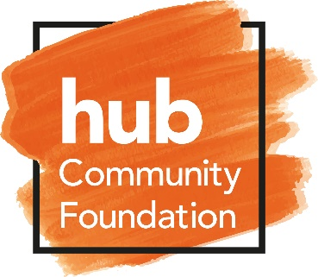
Hub Community Foundation
Position: Independent Trustee
Primary Location: UK
Overview

HCF was established to fund charitable activities which were considered complementary to the Scotland-wide hub programme which delivers community infrastructure, for the benefit of all of Scotland’s communities.
There are five regional hub territories which collectively cover the whole of Scotland and each territory is operated by a regional HubCo. In each HubCo there is a Private Sector Development Partner (PSDP) who each hold a 60% equity share and each PSDP is a Member of HCF.
Scottish Futures Trust (SFT) has an overarching responsibility for the co-ordination of the hub programme across Scotland. SFT is also a Member of HCF.
HCF is working in partnership with Inspiring Scotland to support young people across Scotland into employability and training.

Through involvement in the Scotland wide hub programme, HCF has raised funds sufficient funds to establish the Building Brighter Futures Fund. After a rigorous application process, the Building Brighter Futures Fund will provide over £1 million, over the next three years, to 10 different charities, to help reduce youth unemployment across Scotland.

This funding will help the charities to continue to deliver great work that helps make a real difference to young peoples’ lives.

Key objectives of the role
Trustees are responsible for the overall governance of the HCF (and associated companies) and ensuring that it operates in a manner which enables it to fulfil the objectives set out in the Memorandum and Articles of Association; that due attention is paid to charitable and company law; that it bears in mind the strategies and aspirations of the HCF and stakeholders and that it upholds the reputation of the HCF.
Key Responsibilities
- Ensure at HCF pursues its charitable aims as set out in its Memorandum and Articles of Association.
- Ensure that the HCF operates within company law, charity law and any other relevant legislation or regulations.
- Attending and contributing to meetings of the Board and attending events or supporting governance committees.
- Act as an ambassador for HCF, safeguarding the values and the good name of HCF.
- Use any special knowledge or experience you have to help the Board reach sound decisions. This may involve studying Board papers, leading discussions, taking a special interest in key issues, and providing advice and guidance on new initiatives or other areas of HCF work in which you have special expertise.
- Contribute to Board performance annually.

Experience
Our Trustee’s provide essential leadership, guidance and governance from their own professional or life experiences. They also play and important role as ambassadors for the charity.
Where possible, the candidate should have some organisational experience and held a management position in the private, public or voluntary sectors. Experience of working on the board(s) or committees of charitable, voluntary or partnership organisations would be valuable, but not essential.
Commitment
The expected commitment as a Board member is a few hours each month, to attend 4 Board meetings a year and also engage in Board discussions and adhoc meetings to approve transactions.
Attributes
We are seeking an individual with values aligned with those of HCF.

Compensation
This is an unpaid role, although reasonable expenses will be reimbursed.
Application Process
For those that are interesting in applying for the role, applications will be accepted via email (enquiries@hcfcharity.org.uk). A member of the board of trustees will then be in touch.

